In this example we want to add an additional screen with enhancement fields at transaction VL01N.

1. Search for the BADI

Tcode SE24

Class: CL_EXITHANDLER

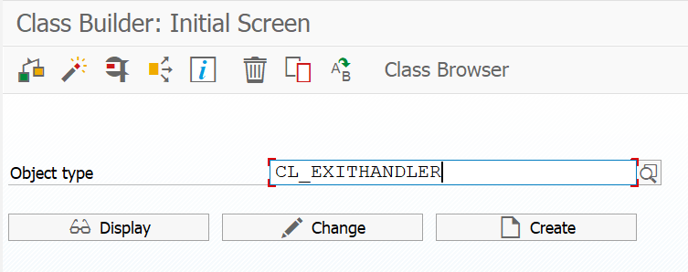

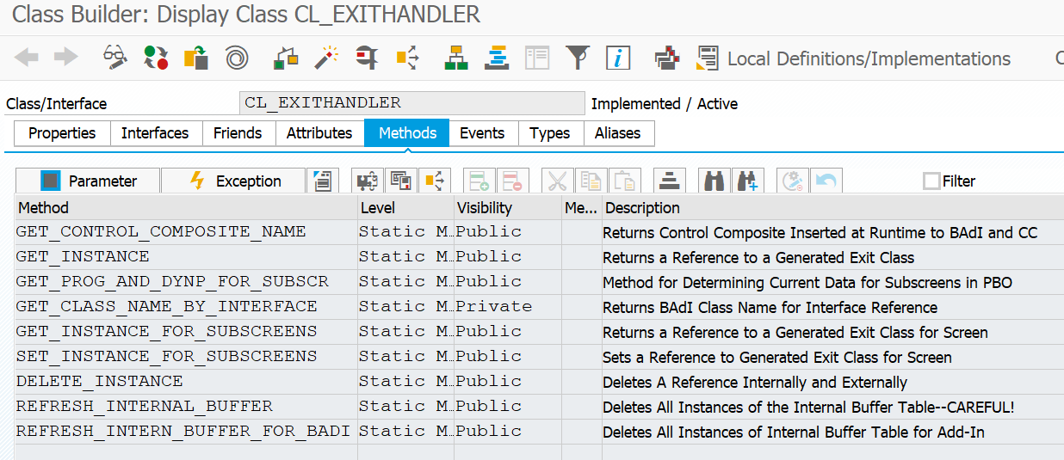

Set a breakpoint as below:

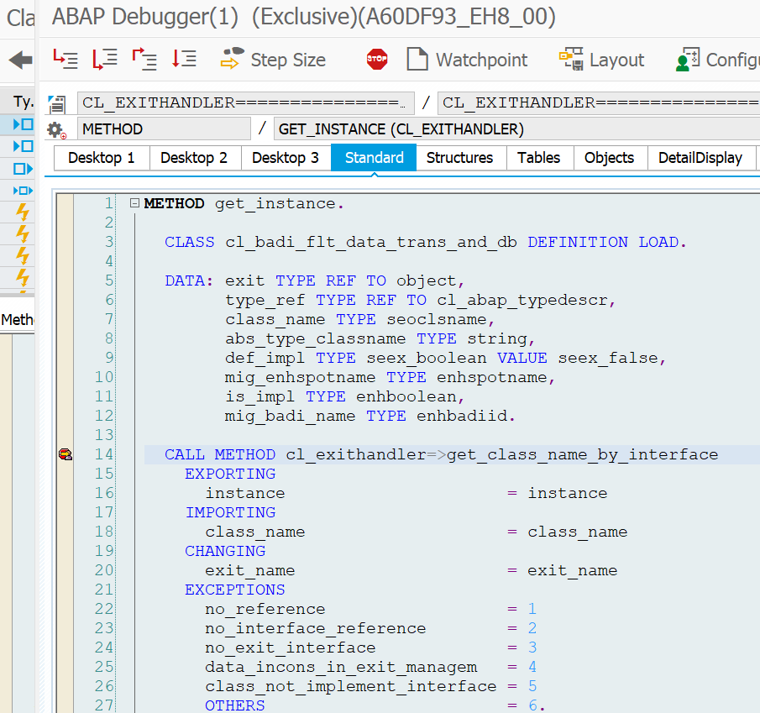

Go to tcode VL03N and check all exit names to see which one can fulfill the requirement.

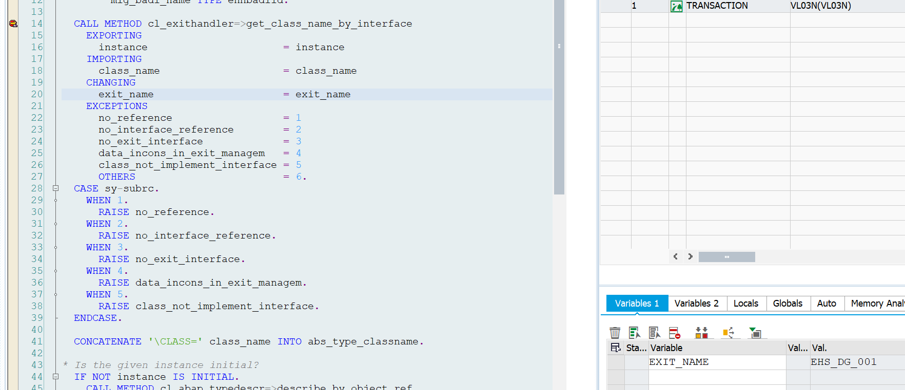

BADI to be used as per the documentation is: LE_SHP_TAB_CUST_HEAD

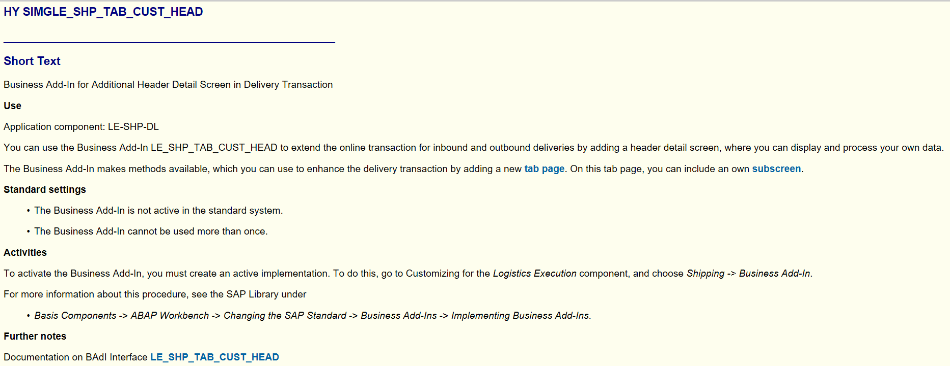

1. Add two fields in the include are of table LIKP (SD Document: Delivery Header Data)

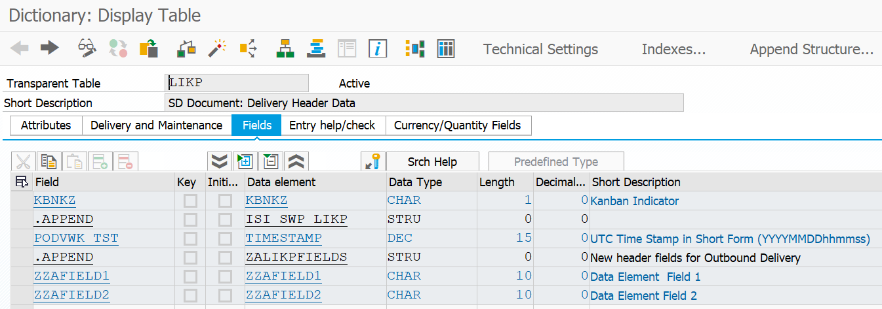

1. Create function group

Tcode SE80 and create a Function Group Z_FGSD01

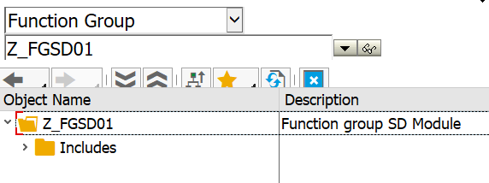

Create a screen, make sure that the Screen Type is ‘Subscreen’.

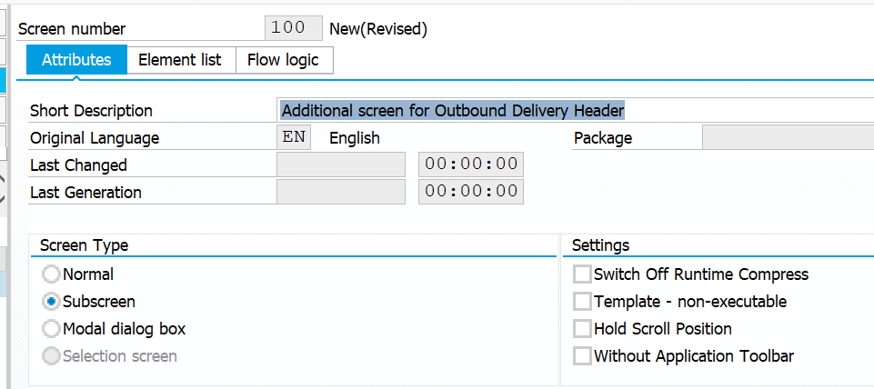

Go to Layout and add the additional fields

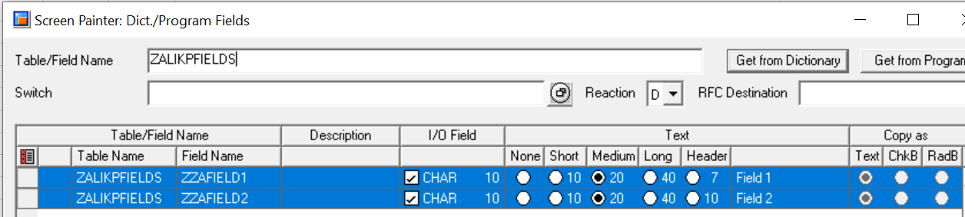

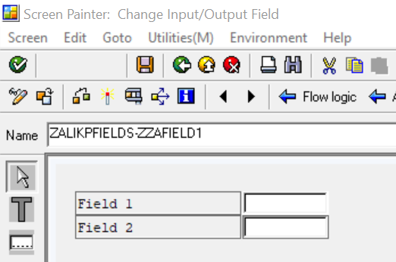

Save, go back and activate the functional group.

When creating a functional group, two includes are automatically generated as follow:

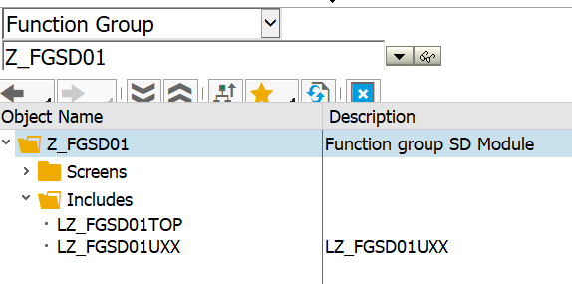

In the include LZ_FGSD01TOP we add the append structure data so the new fields will be available for the program.

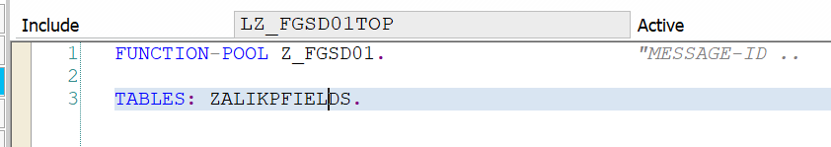

Activate the include.

Create a function model to export data from the standard program to the screen exit.

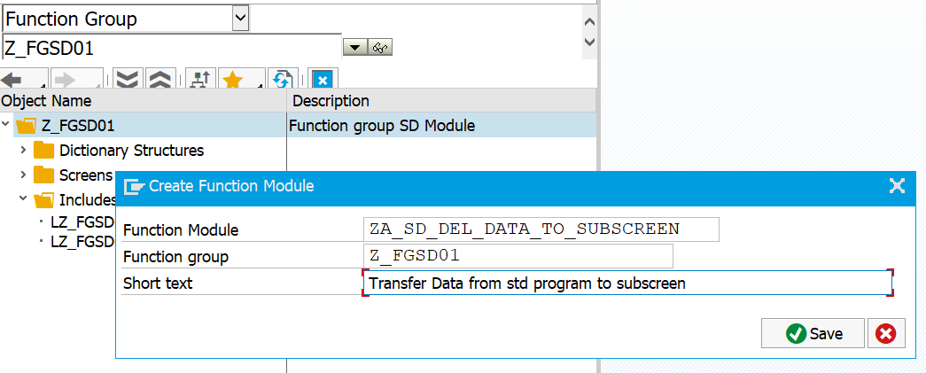

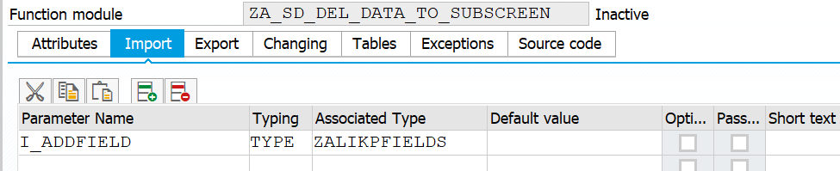

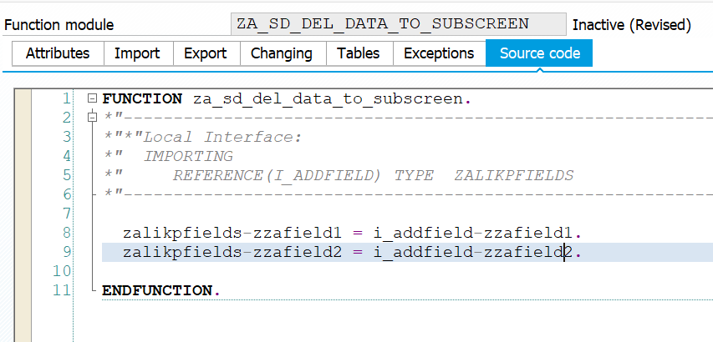

Create a function model to export data from the screen exit to the standard program.

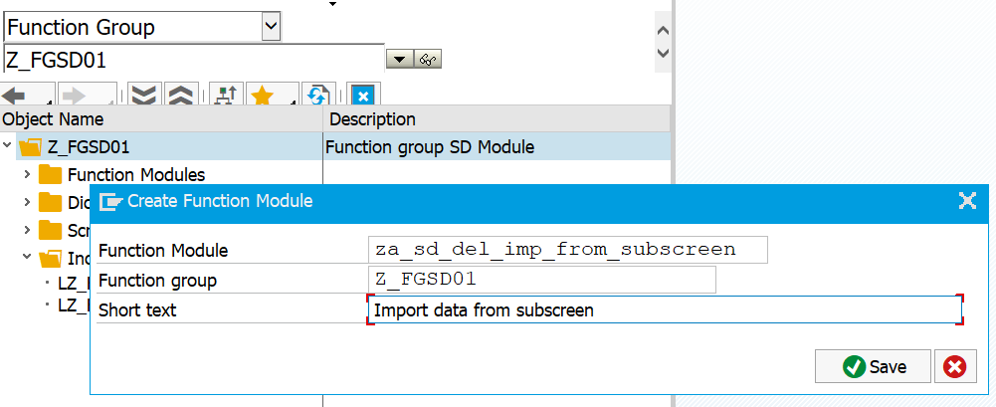

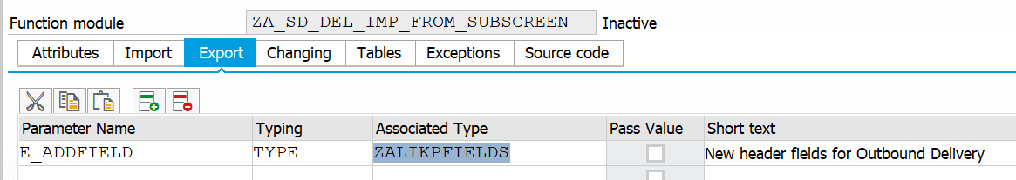

1. Implement the BADI

Tcode SE19

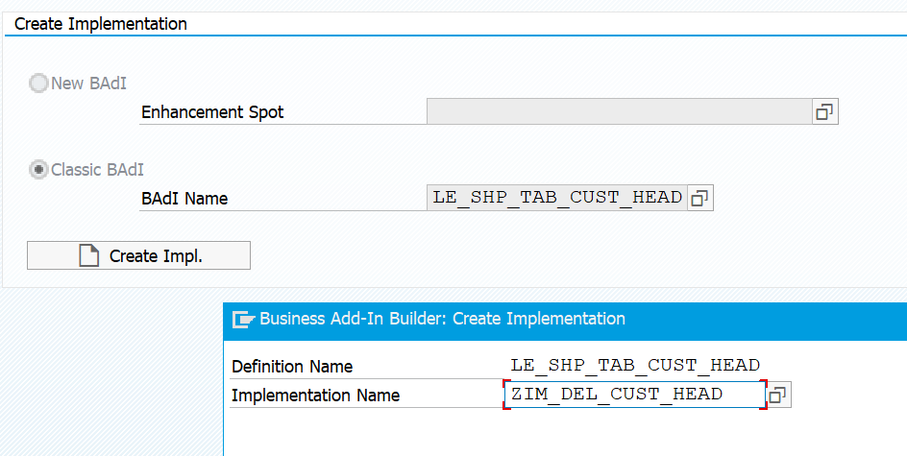

Go to Method ACTIVATE_TAB_PAGE

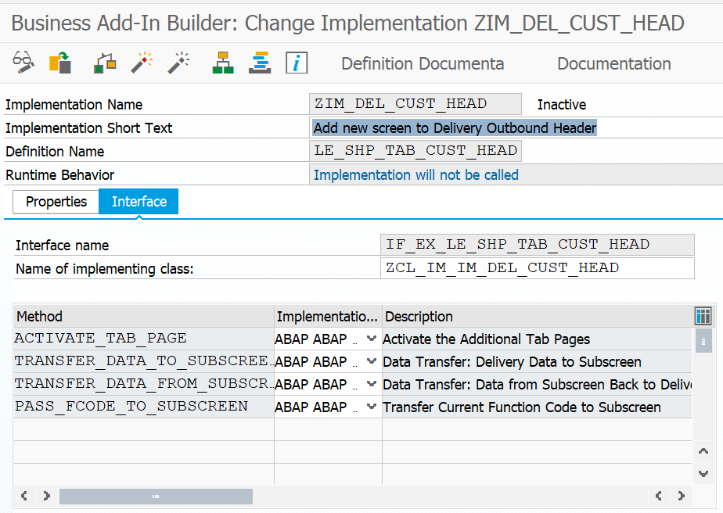

Find the function group program name to be used in the BADI:

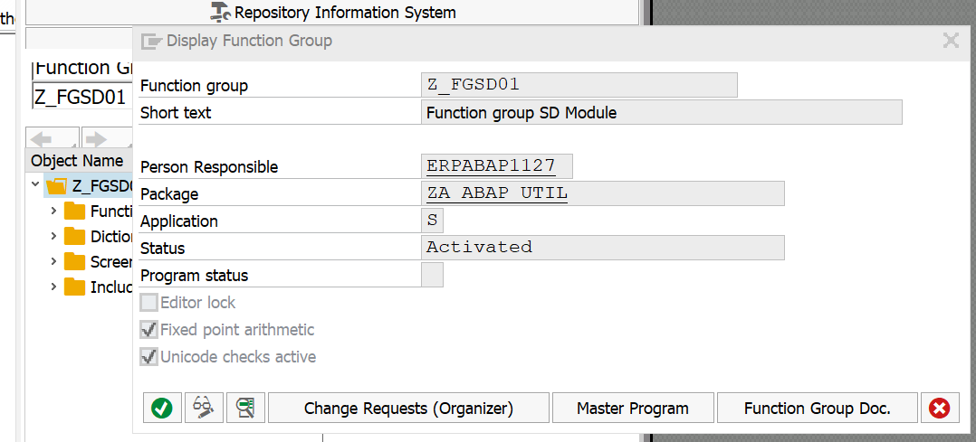

Program name: SAPLZ_FGSD01

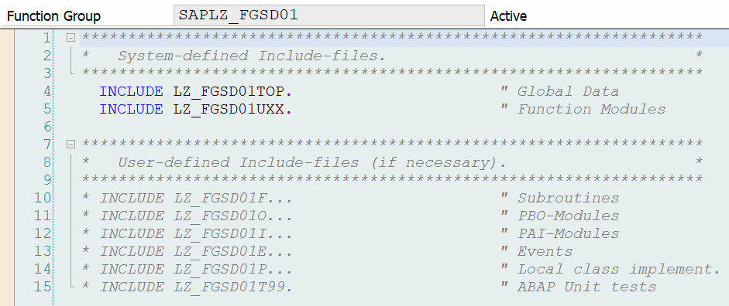

Implement the BADI code as below:

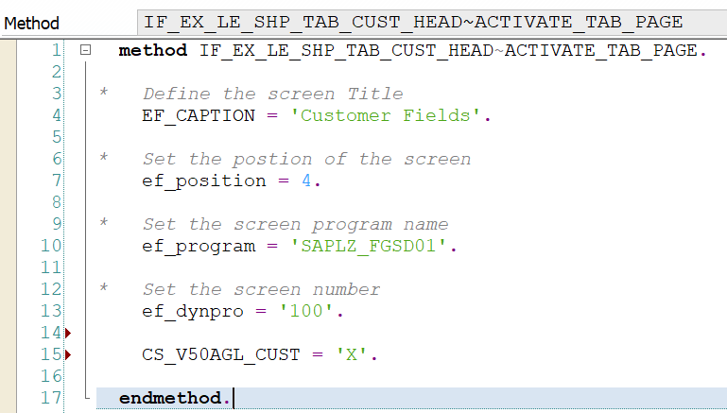

Save and activate.

Go to Method TRANSFER_DATA_TO_SUBSCREEN.

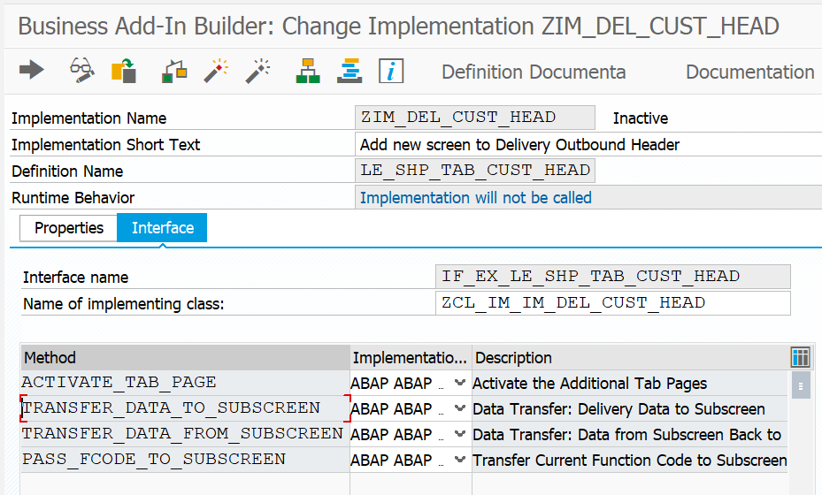

Here we use the FM we have created as part of the function group: ZA_SD_DEL_DATA_TO_SUBSCREEN.

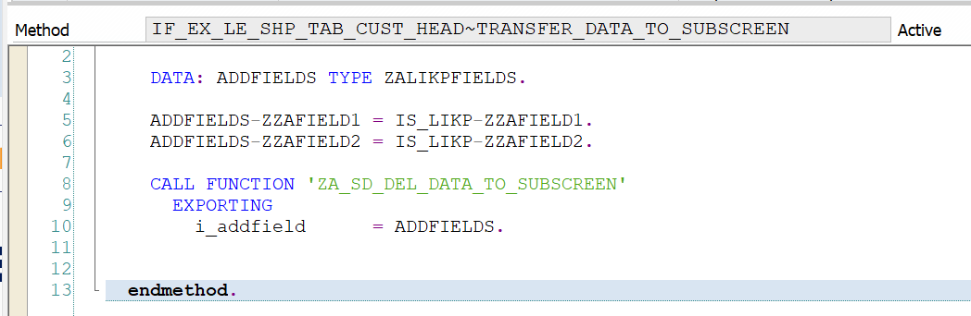

Go to Method TRANSFER_DATA_FROM_SUBSCREEN



Here we use the FM we have created as part of the function group: ZA_SD_DEL_IMP_FROM_SUBSCREEN

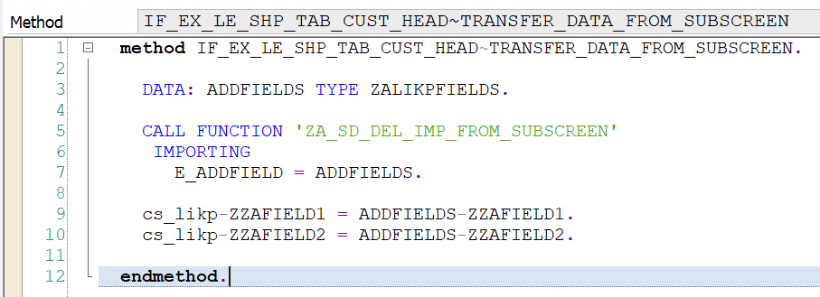

1. Test

Open tcode VL03N and navigate to the header. See that there is a new tab “Customer Fields”

